Activity No. <n>
<Replace with Title>
Course Code: CPE010 | Program: Computer Engineering
Course Title: Data Structures and Algorithms | Date Performed:08/07/25
Section:CPE11S1 | Date Submitted:08/07/25
Name(s): Cenndy M. Nieles | Instructor: Engr.Jimlord Quejado
6. Output:

1.Erroor:
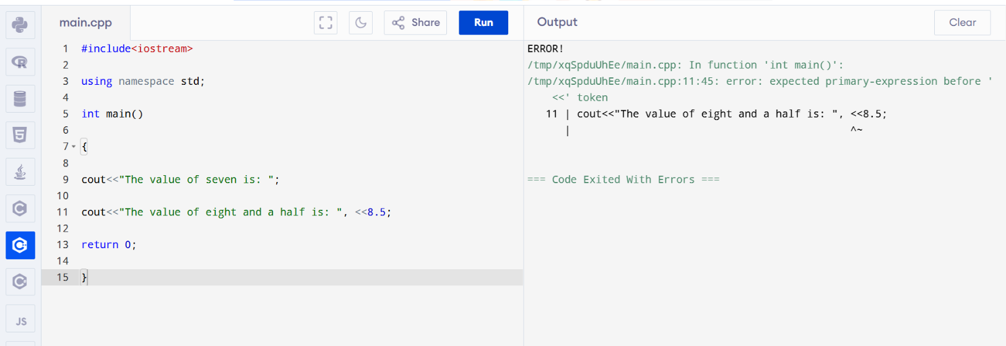
Result:
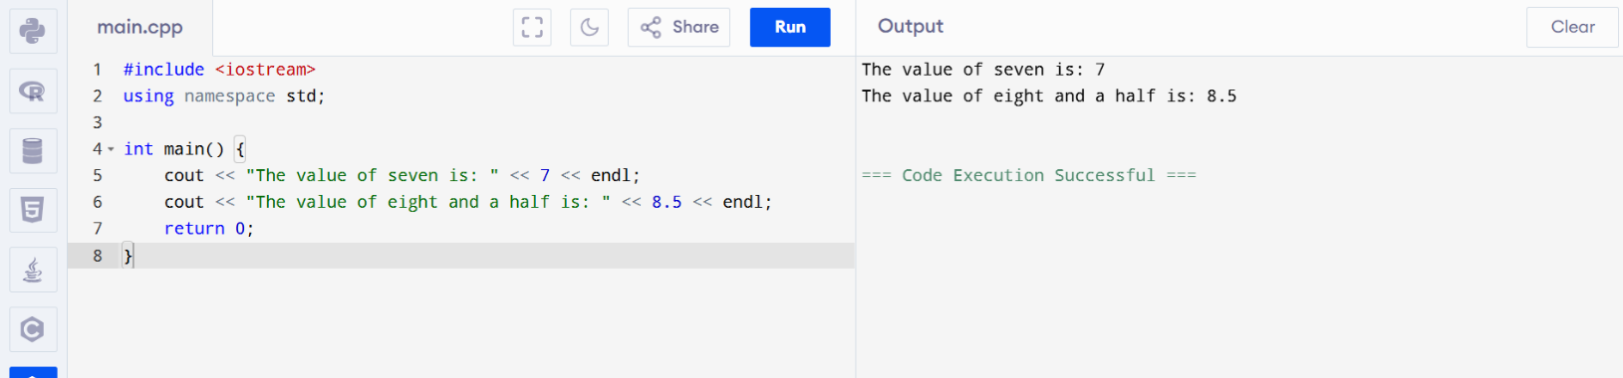

2.ERROR:
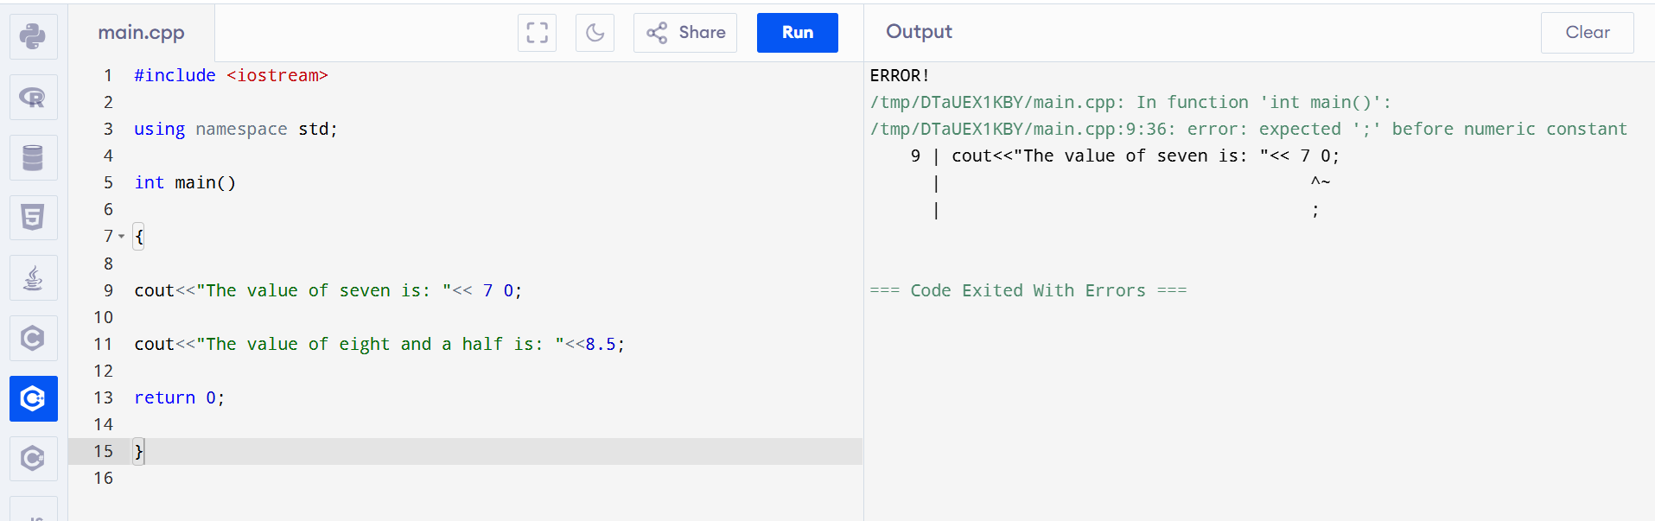

RESULT:

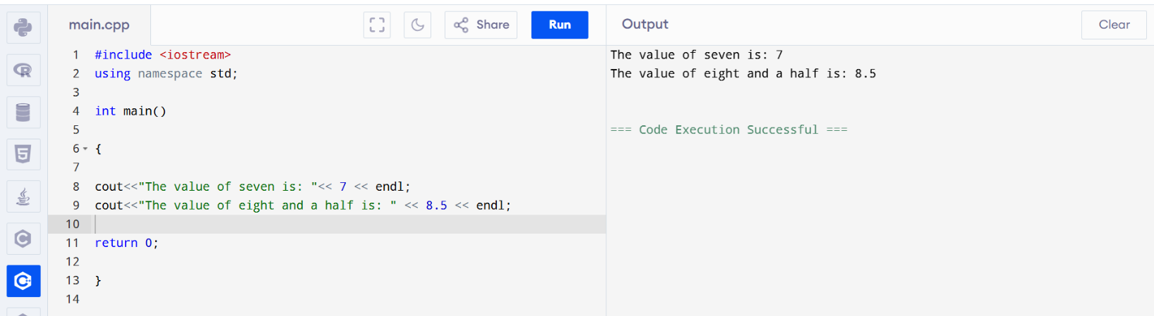
3.ERROR:
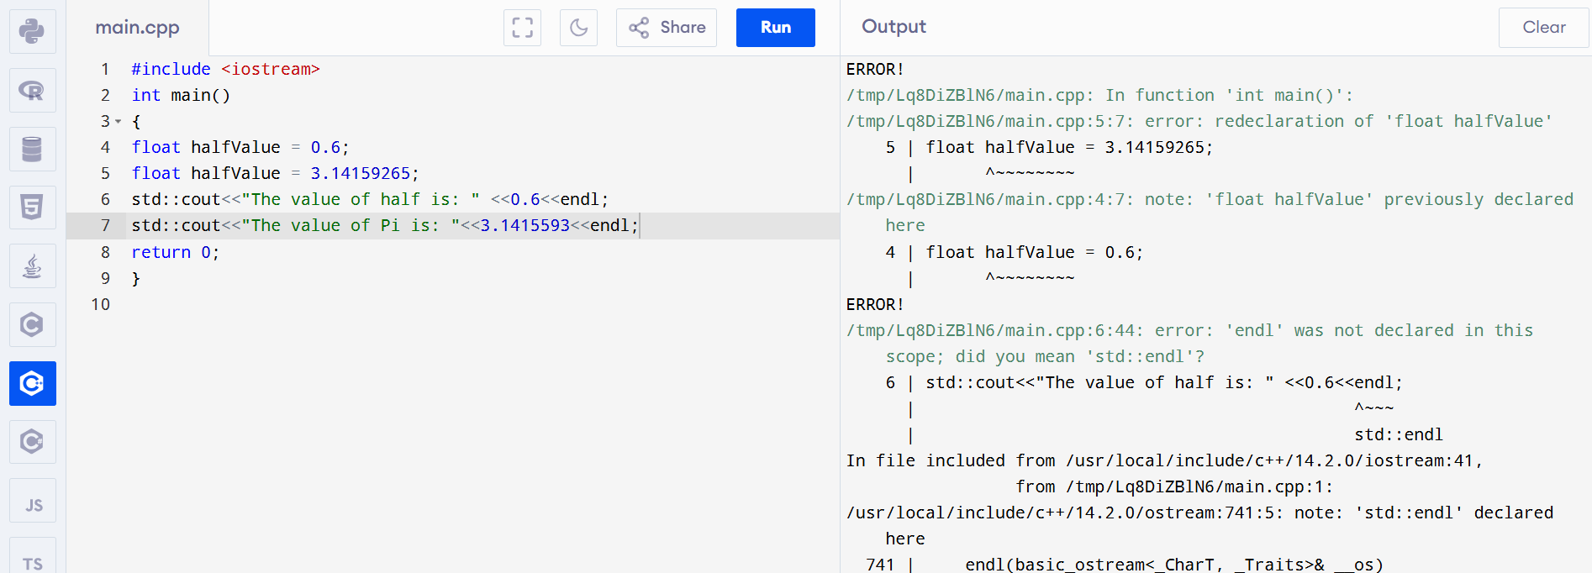
RESULT:
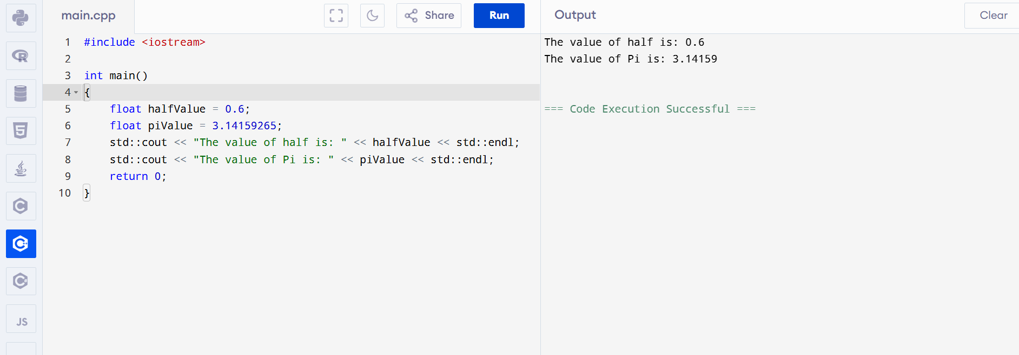

4. ERROR:

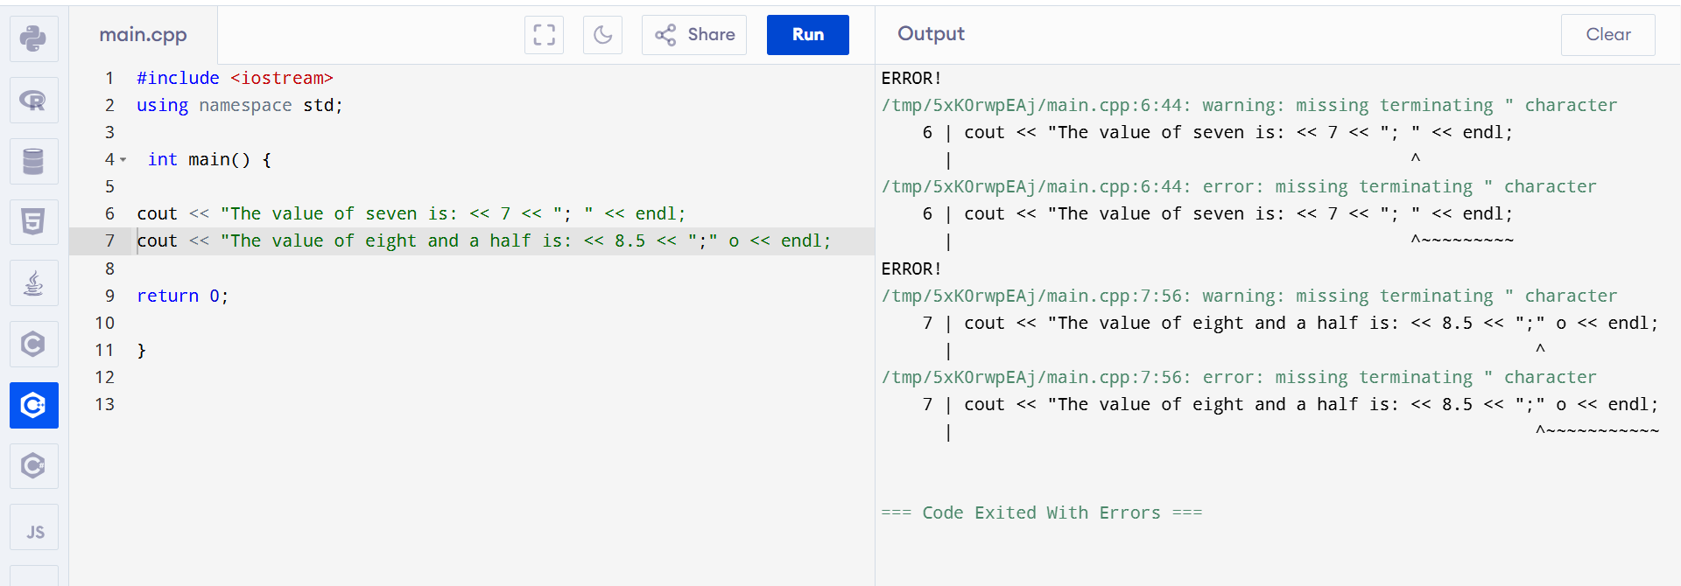
RESULT:
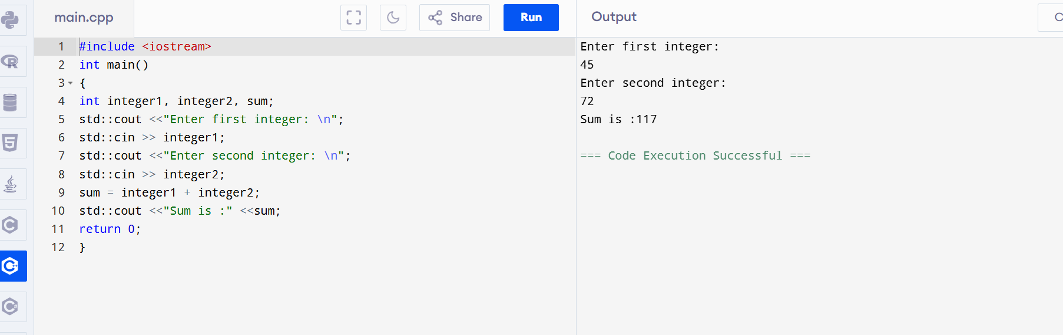

7. Supplementary Activity:

Activity 1
#include <iostream>
using namespace std;
int main(void)
{
int xValue=5;
int yValue=9;
int result;
int bigResult;
/*
increment xValue by 3
decrement yValue by xValue
multiply xValue times yValue giving result
increment result by result
decrement result by 1
assign result modulo result to yValue
increment result by result added to xValue
assign result times result times result to bigResult increment result by xValue times yValue
*/

cout<<"result: "<<result;
cout<<"big result: "<< bigResult;
return 0;
}

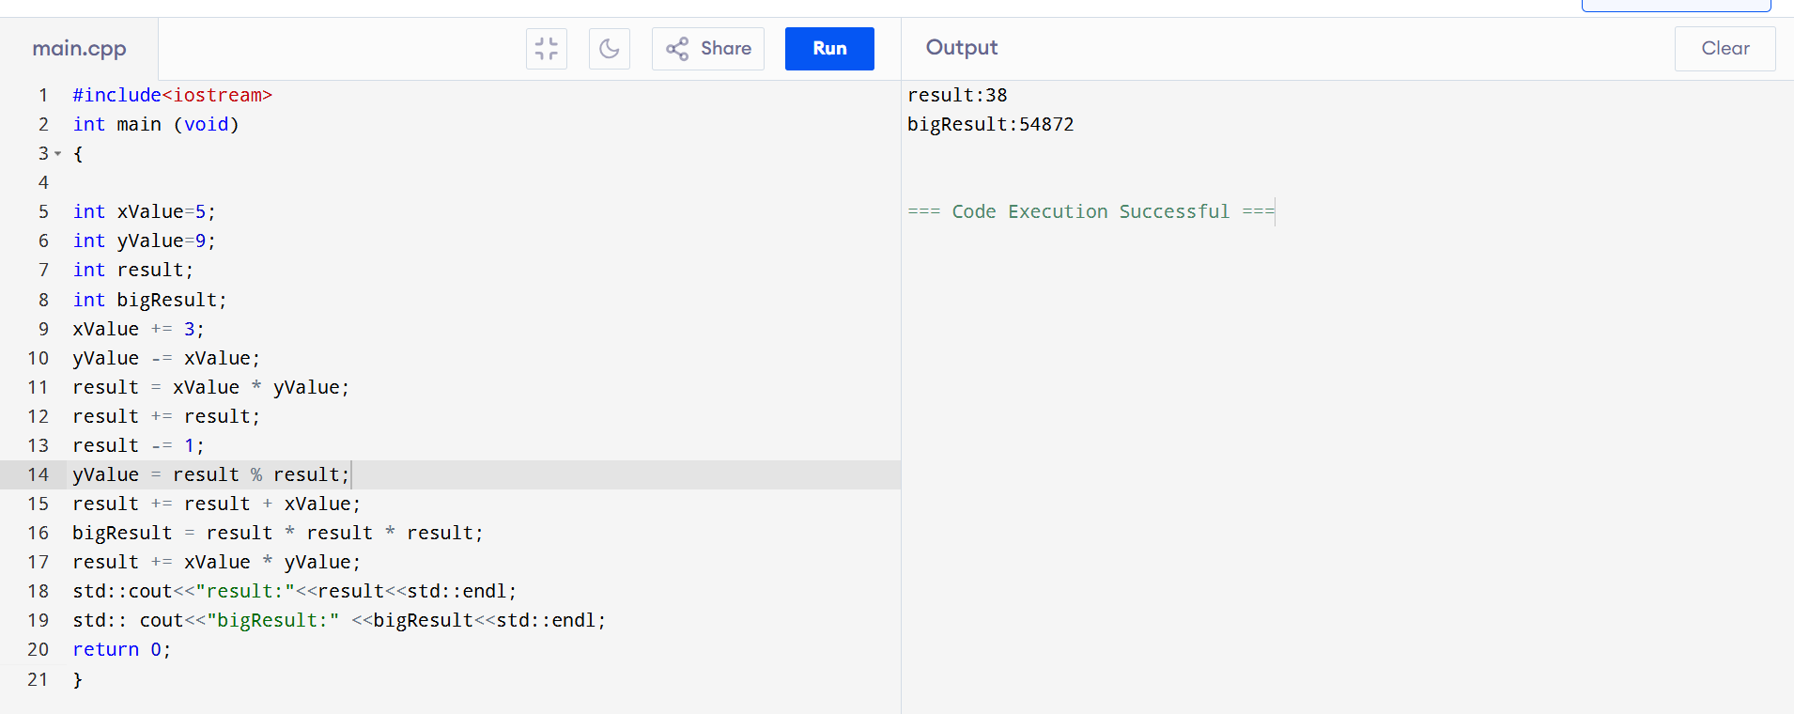

Activity 2:

#include <iostream>
using namespace std;
int main()
{
float startValue = 100;
float interestRate = 0.015;
float firstYearValue;
float secondYearValue;
float thirdYearValue;

/* Your code */

cout<<"After first year: "<<firstYearValue;
cout<<"After second year: "<<secondYearValue; cout<<"After third year: "<<thirdYearValue;
return 0;
}
Example output
After first year: 101.500000
After second year: 103.022499
After third year: 104.567833

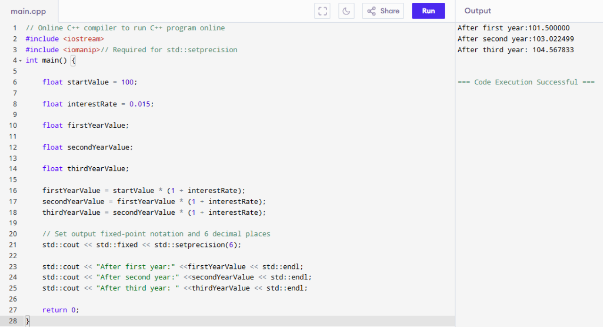

8. Conclusion: First you need to understand the problem the fundamental of data types and organize data, to restore and retrieve data performance and to solve specific problem is fundamental in programing and data analysis .Data types-such as integers, floats, strings, and determine what kind of data can be stored and manipulated. This activity aims to develop programming skills in structuring data types and arithmetic operations.
9. Assessment Rubric

